Selenium Frameworks | Data-Driven | PART -1 | Why do we need Data-driven Framework | Introduction

Writing code to test functionality is a great thing but writing the code effectively to accomplish the function is even greater. Our code should perform the desired operation in less number of lines. Rewriting the code, again and again, is not the best practice and that will make our project unmanageable. Our code should be reusable, manageable, scalable, cost-effective and so on. This is where frameworks come into the picture.

Frame work should be Reusable, Organised, Manageable, Understandable , Scables, Cost effective, certain rules & standard

Requirement:
Url : https://opensource-demo.orangehrmlive.com/web/index.php/auth/login
Test the above with 1.Correct username & PW, 2. Incorrect username & PW

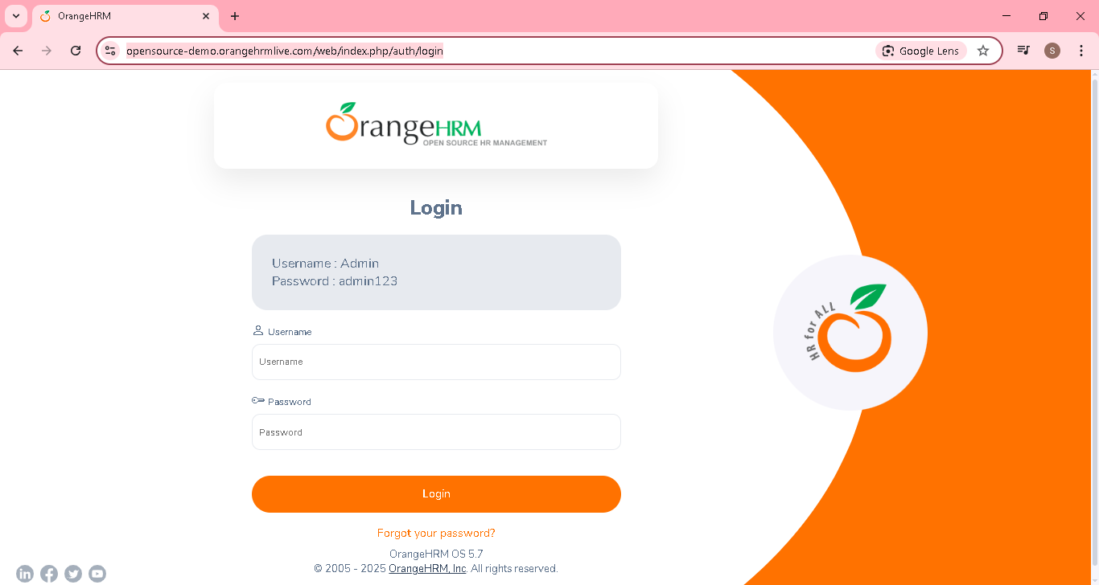
Test the above with 1.Correct username & PW, 2. Incorrect username & PW
Create a java project , then package & 2 class for .Correct username & PW, 2. Incorrect username & PW

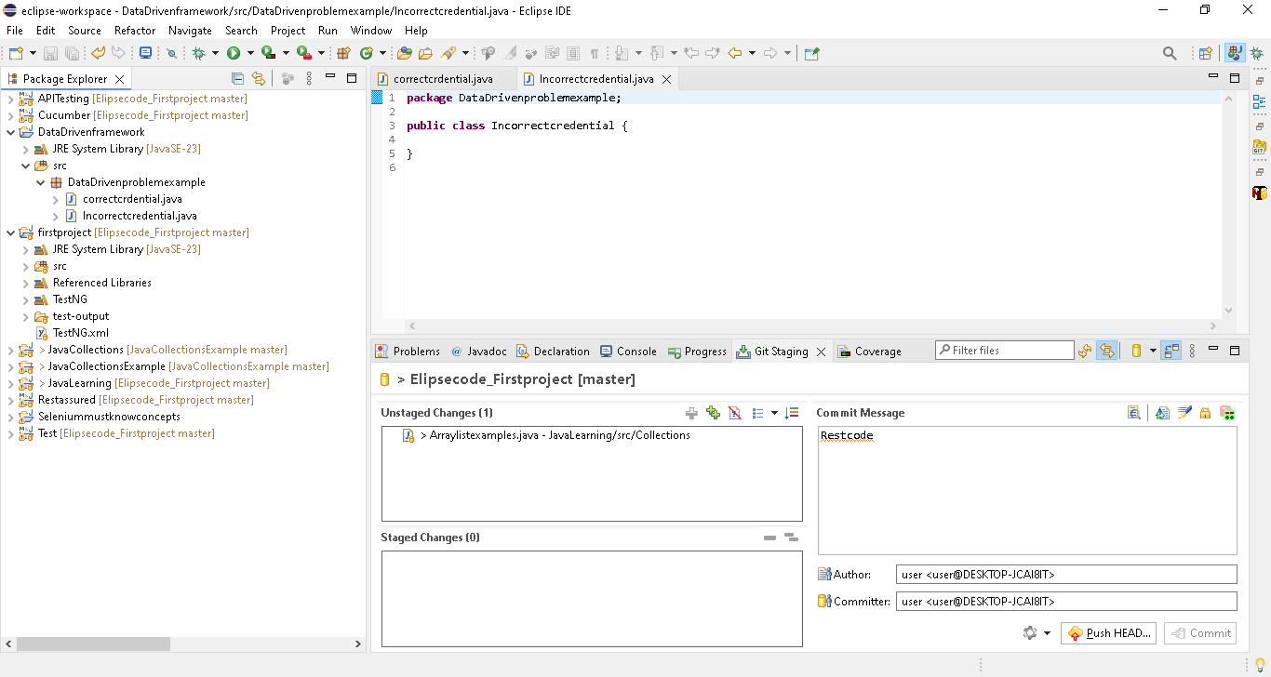

Add the selenium & testng jar
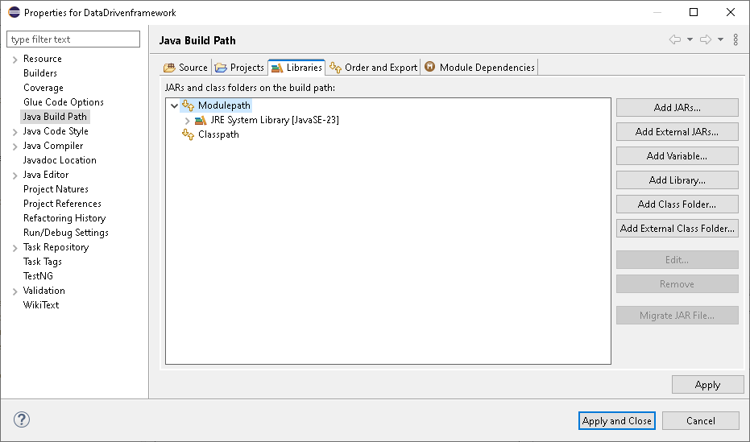

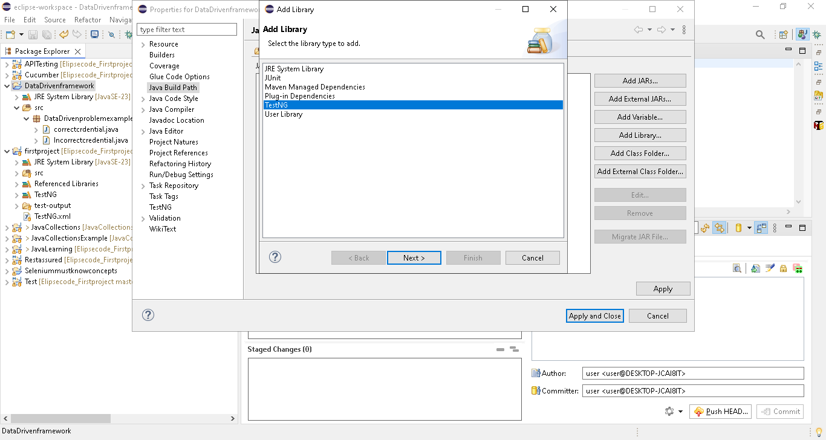

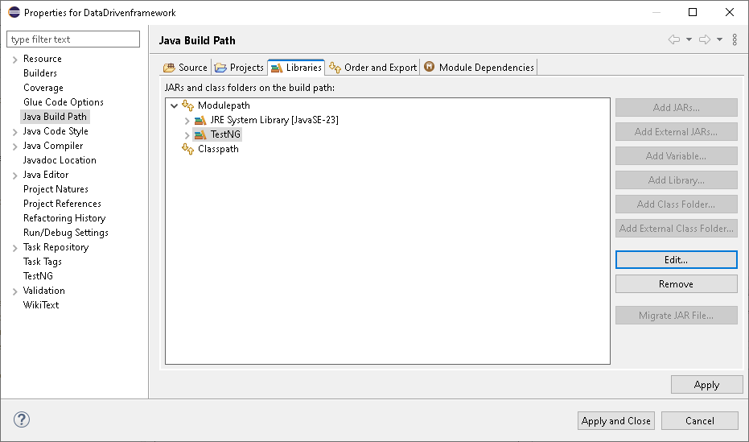

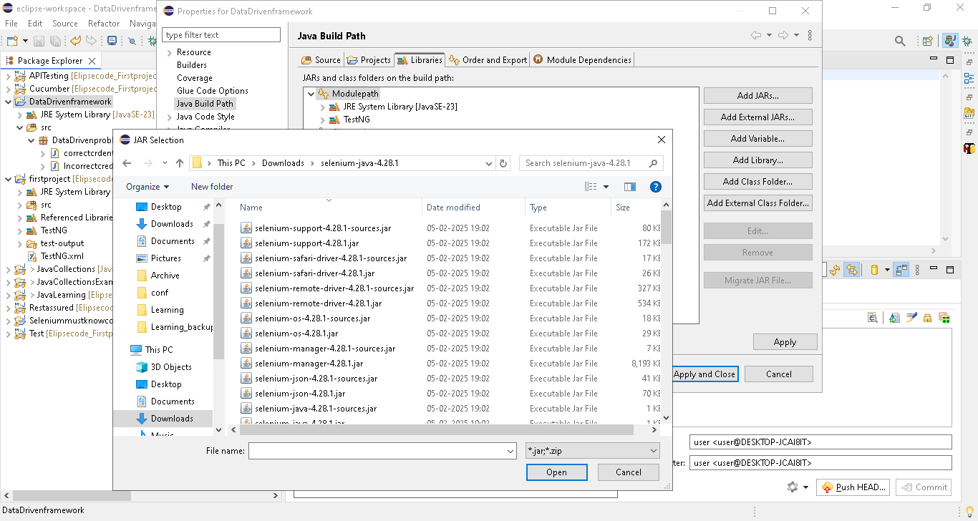

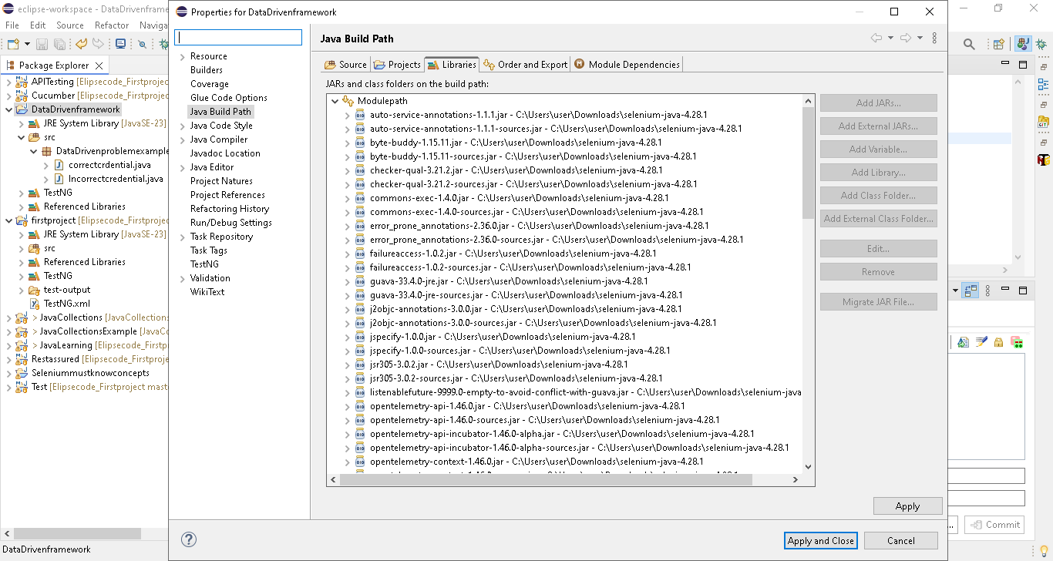

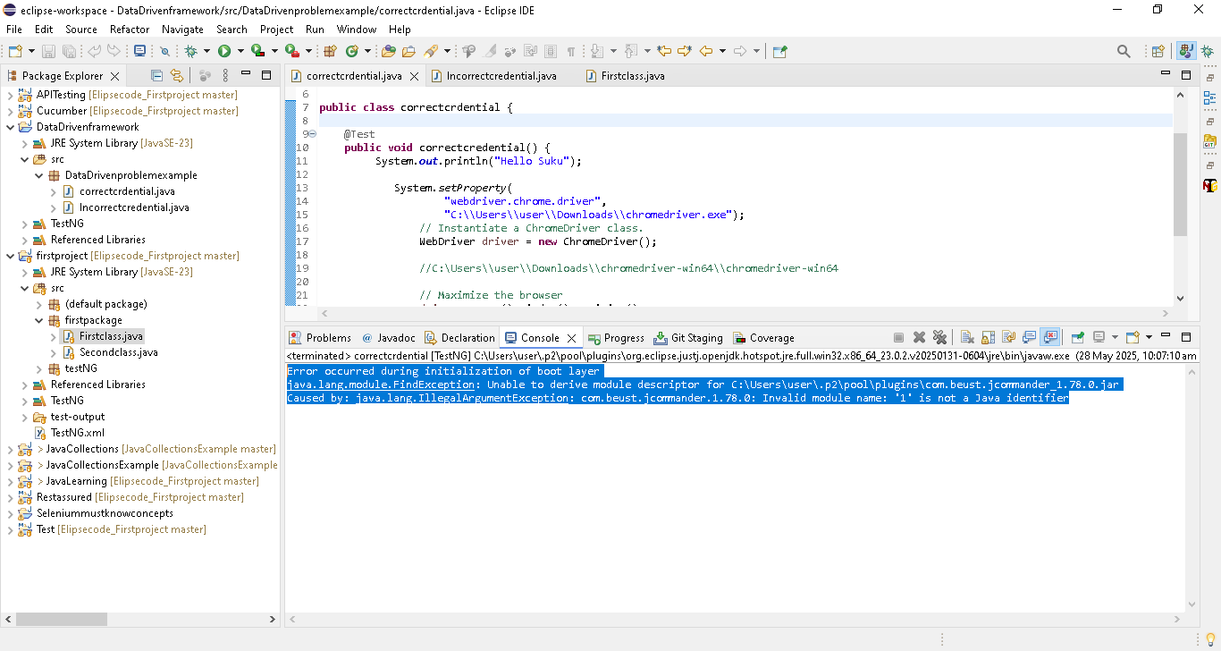

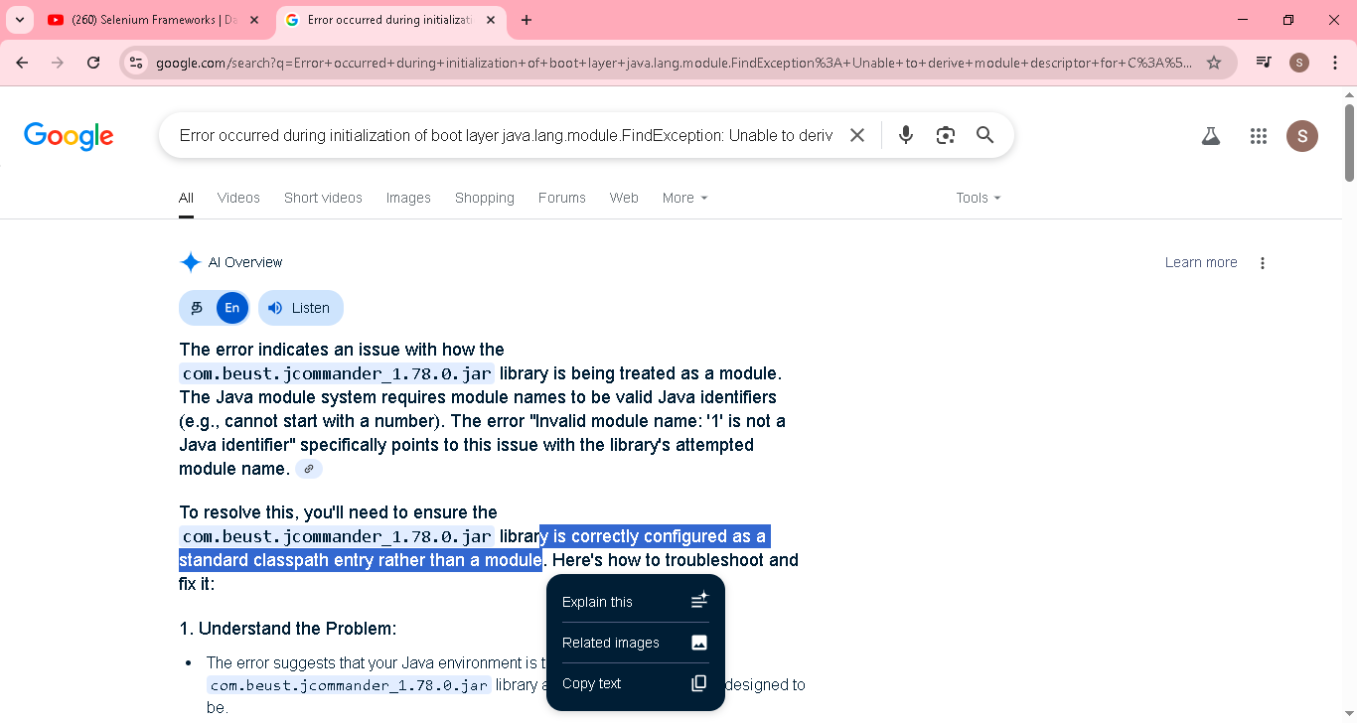
That means we need to add jar in classpath not in module path
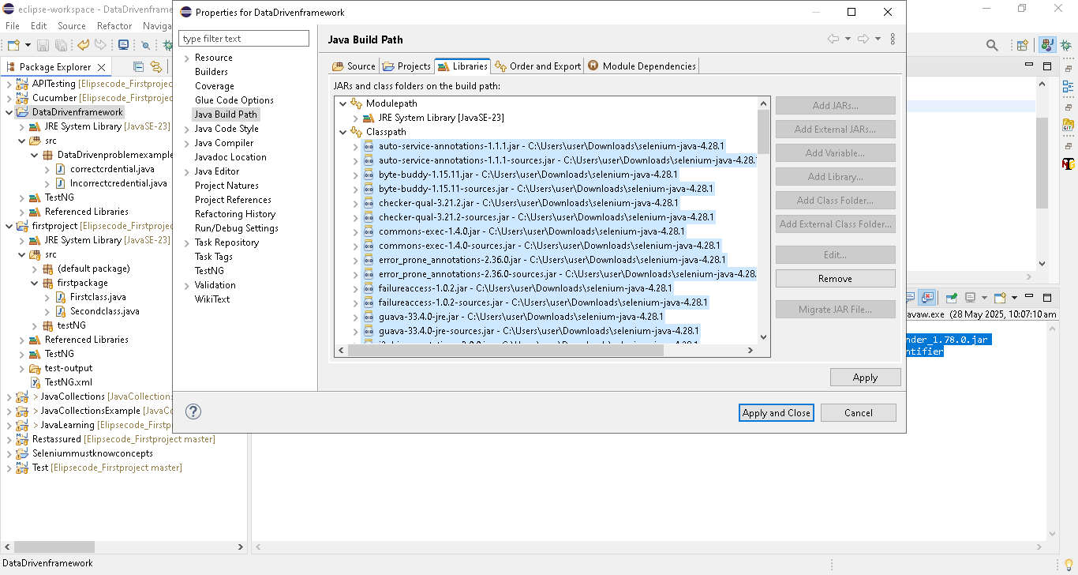

Now its worked
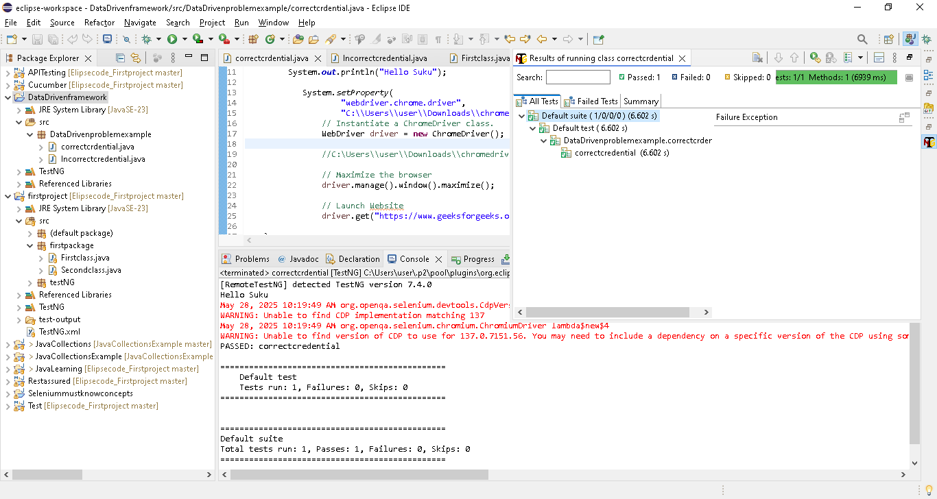
Correctcredential
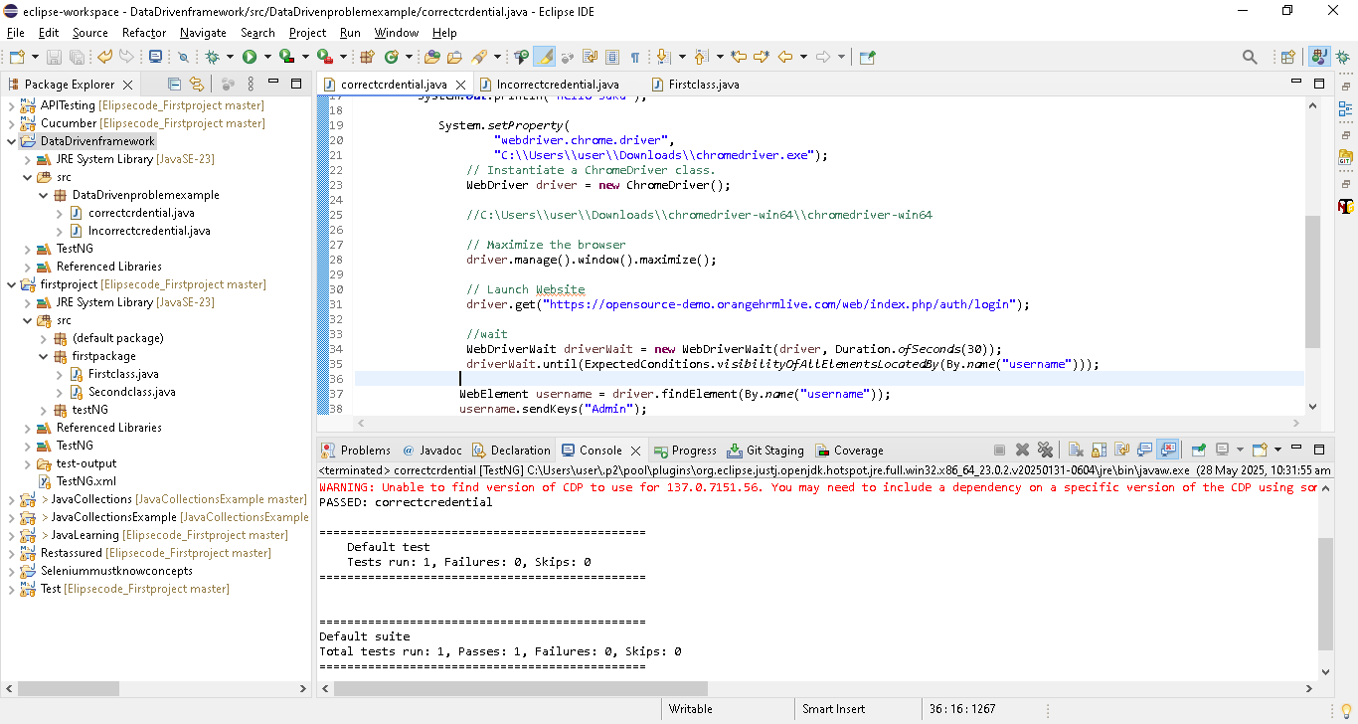
Incorrect credential
Copy the same code & paste it..just change the id and PW
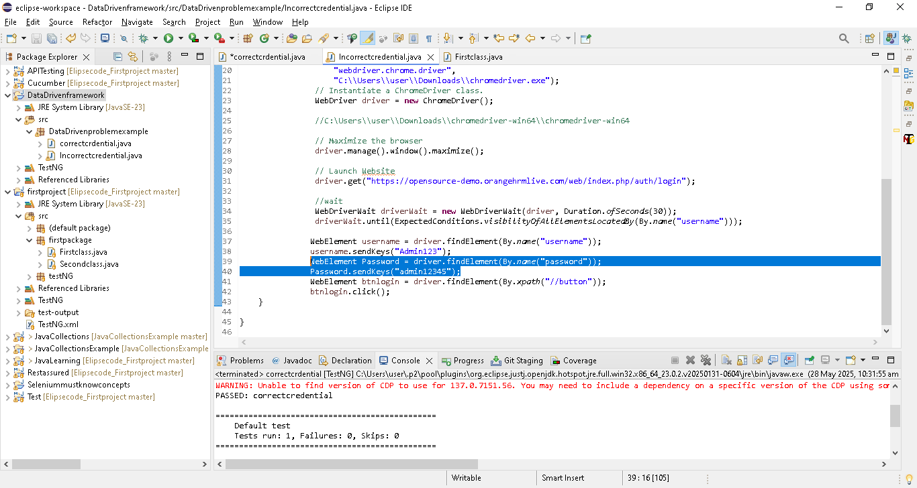

Create as testng.xml & run both the class
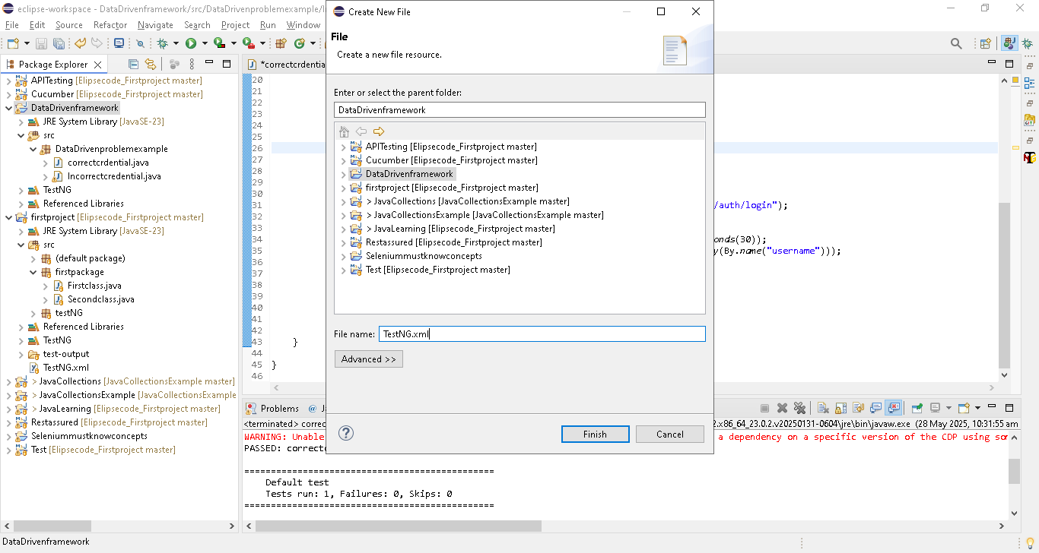

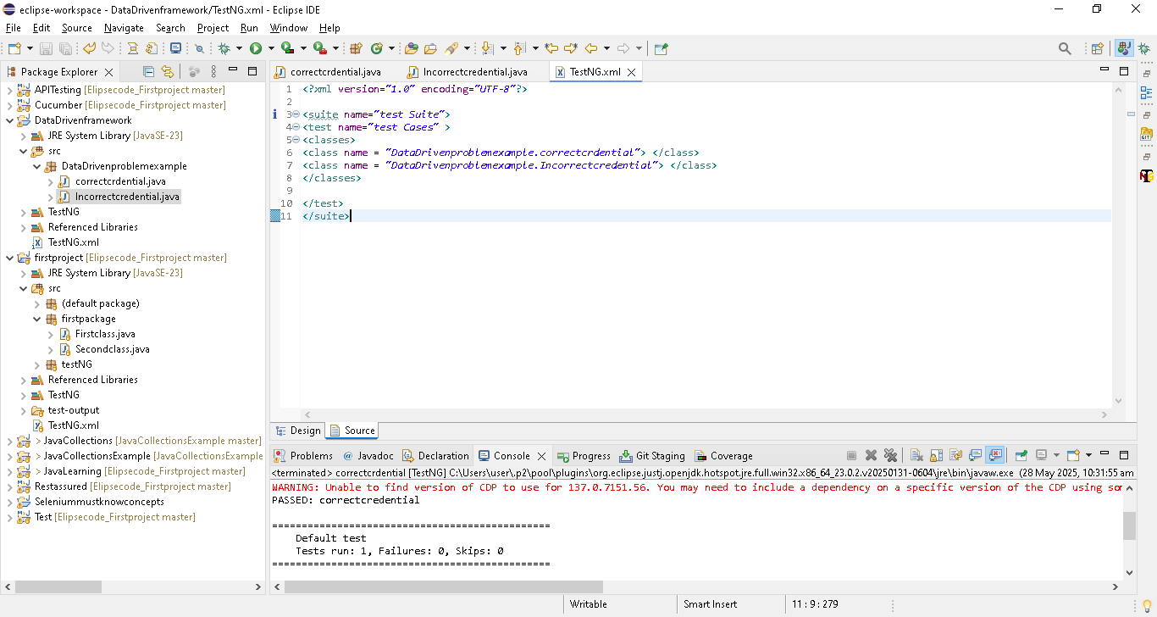

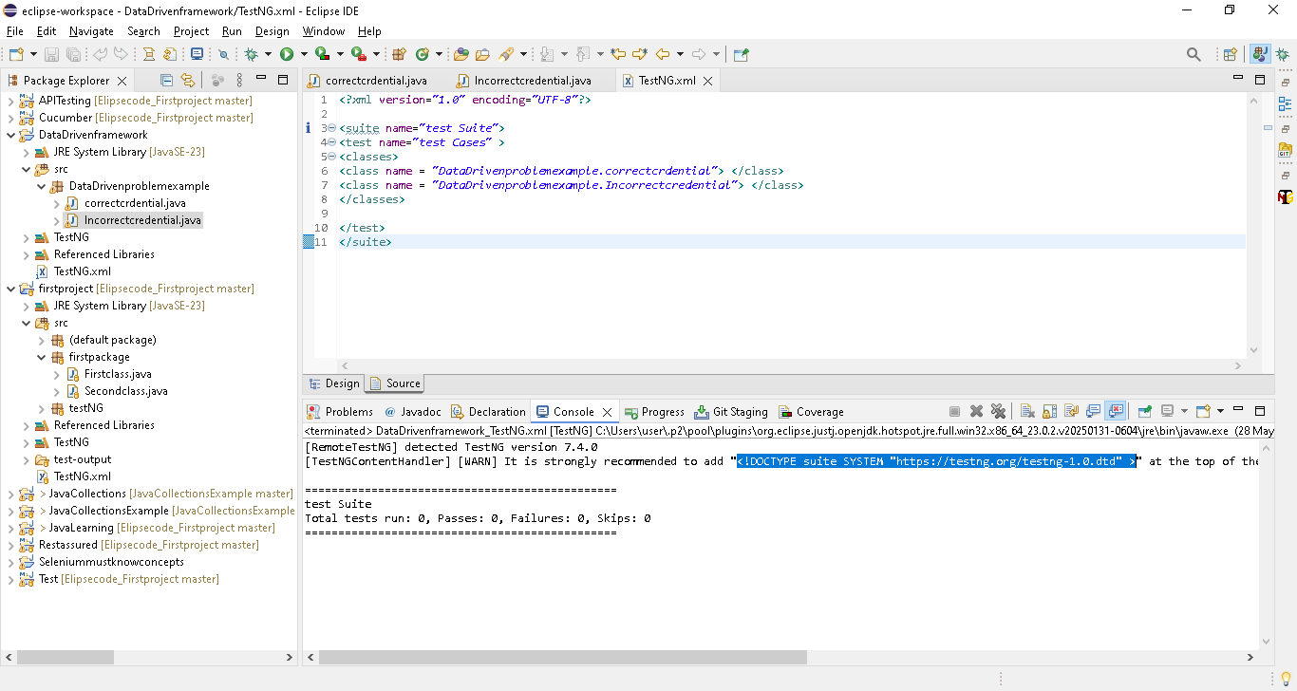

<!DOCTYPE suite SYSTEM "http://testng.org/testng-1.0.dtd" > add in the xml
Go to window ->Preference -> XML(wild web developer)->enable download external resources & apply
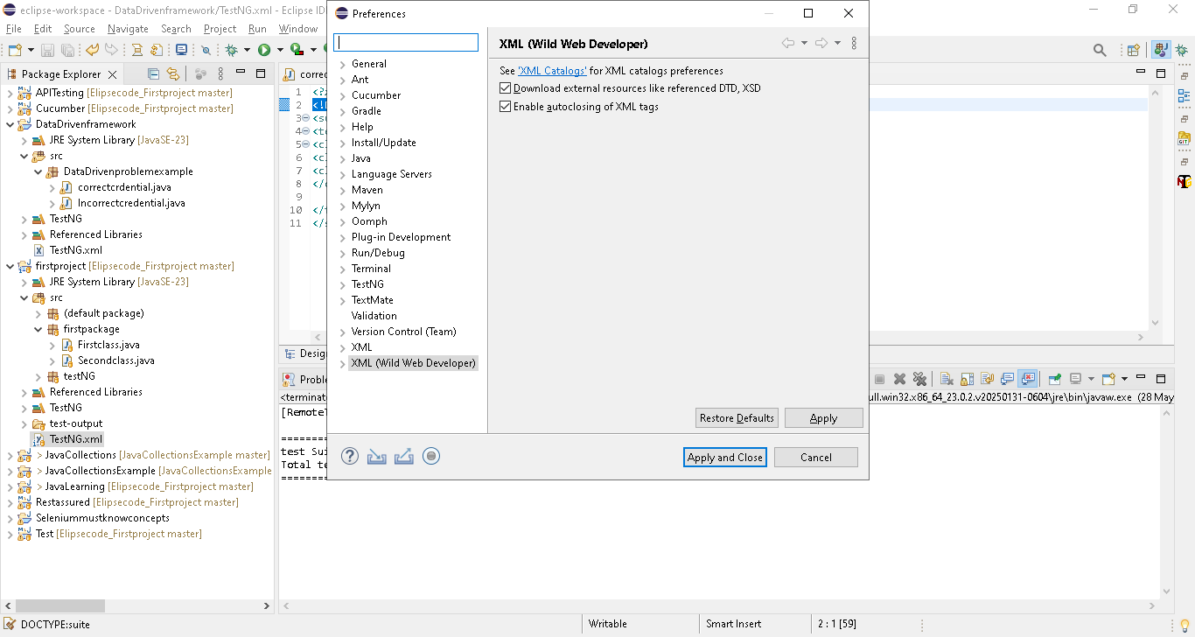
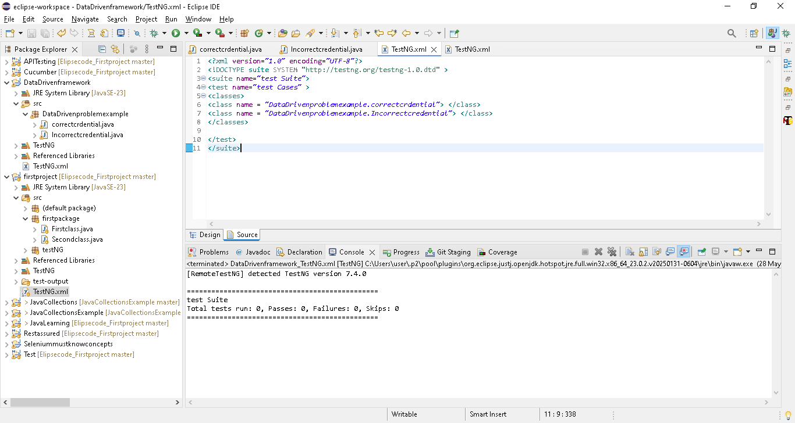

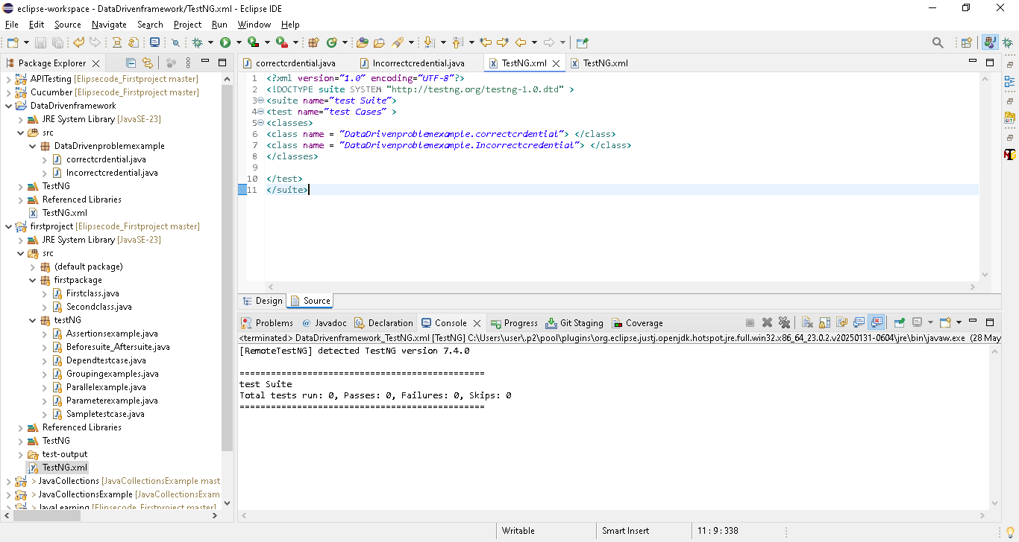
Executed, no response..because @test is missed in method..add it
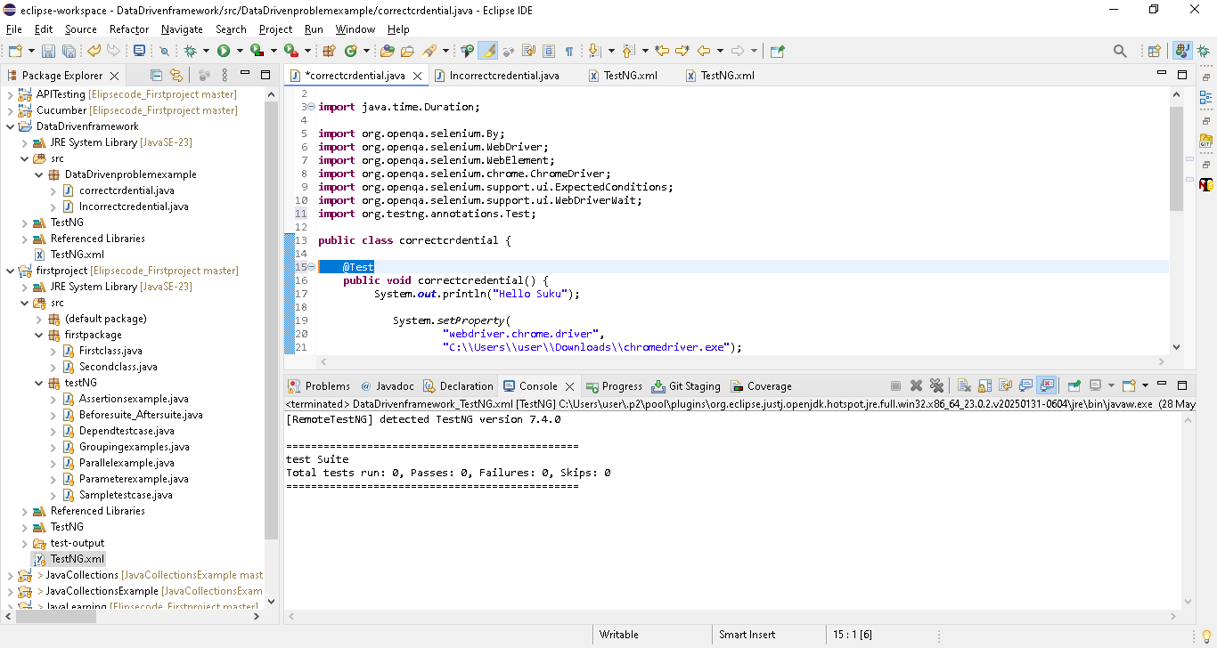

Now worked
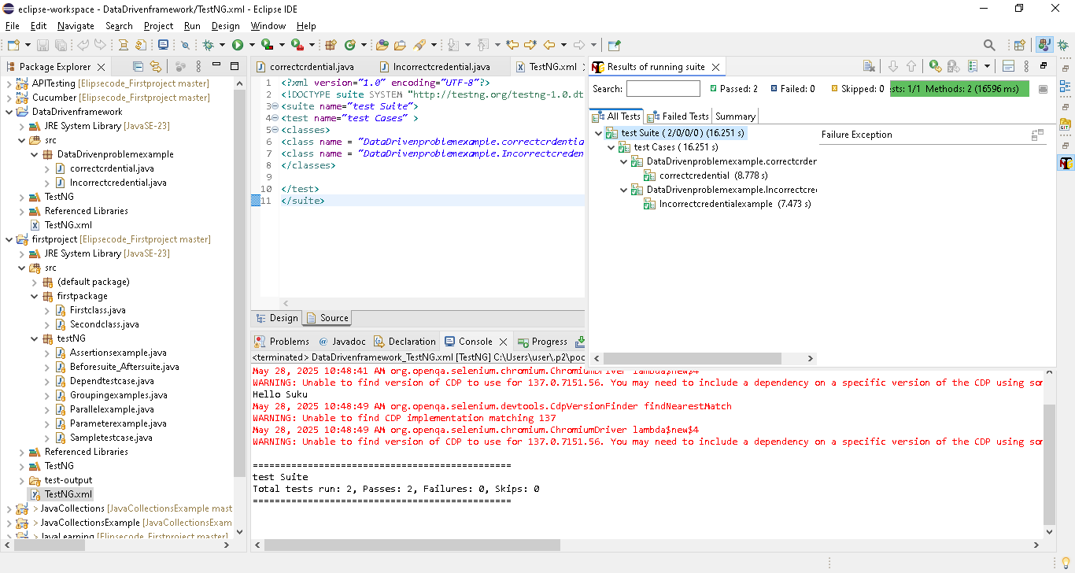

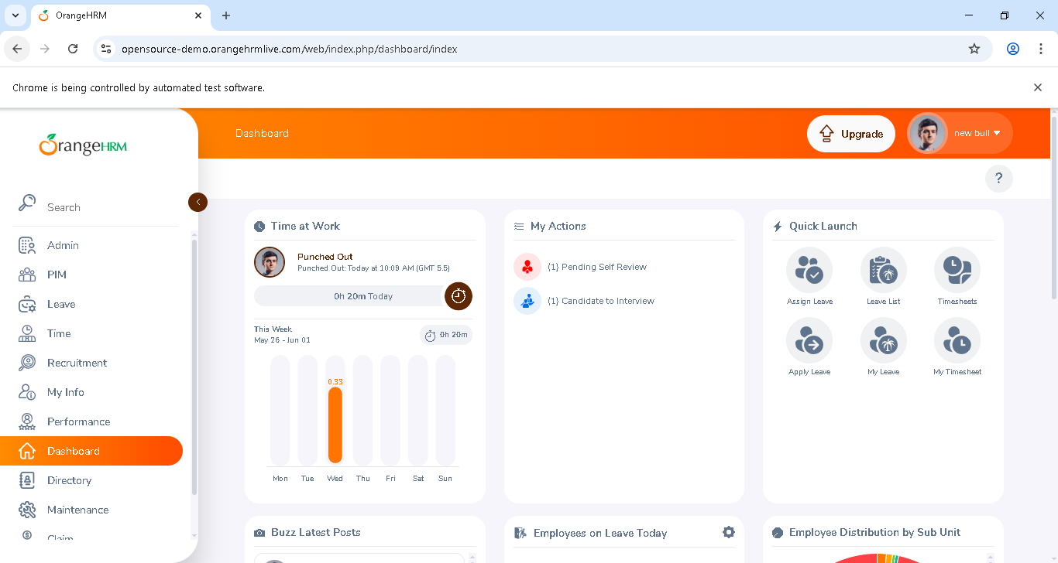

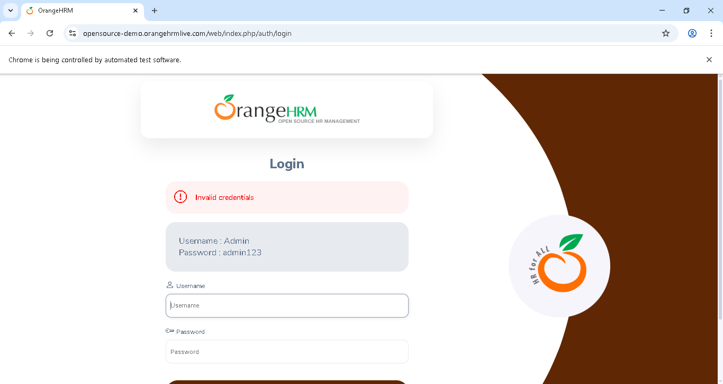

So above approach is a best one for the requirement..definitely No..
Requirement:
Test the above with 1.Correct username & PW, 2. Incorrect username & PW
Both class having same line of codes, only data is different..need to minimize the code with upcoming data driven framework approach
And also username & PW also inside the method..it should be read external like in excel or testng..
If login details changed in further..then we can directly update in outside

Selenium Frameworks | Data-Driven | PART - 2 | Using TestNG Parameters for Data driven testing

TestNG provides a lot of support for data-driven testing. Parameters are given via testng.xml file and to receive them, we have @parameters annotation in TestNG.
What will we learn in this video:
1. How to use parameters in TestNG for data-driven testing?
2. Disadvantages of using Parameters for data-driven testing.
3. How to overcome the disadvantage of using parameters?

Test-output folder created
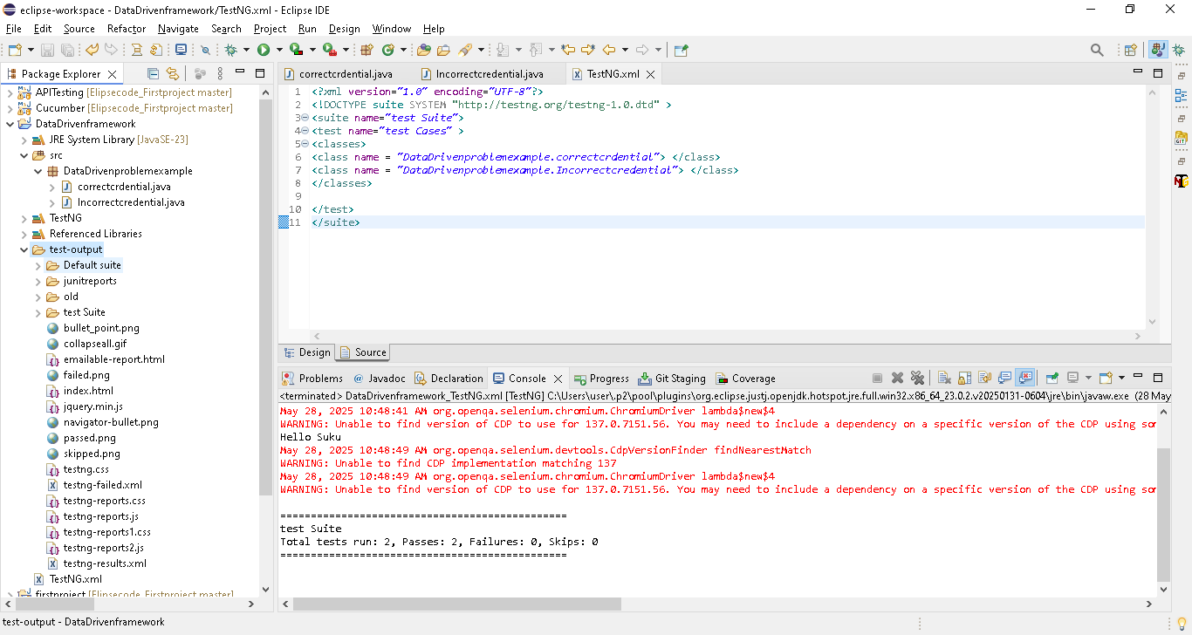
Open the index.html [right click open as web browser)
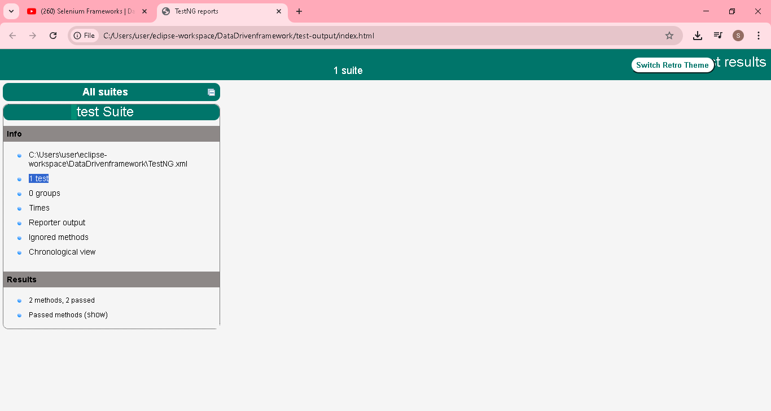

We have executed 2 test..here showing only 1 test
Because we have define all class in one test<test> in testng.xml..
Modify the testng.xml..
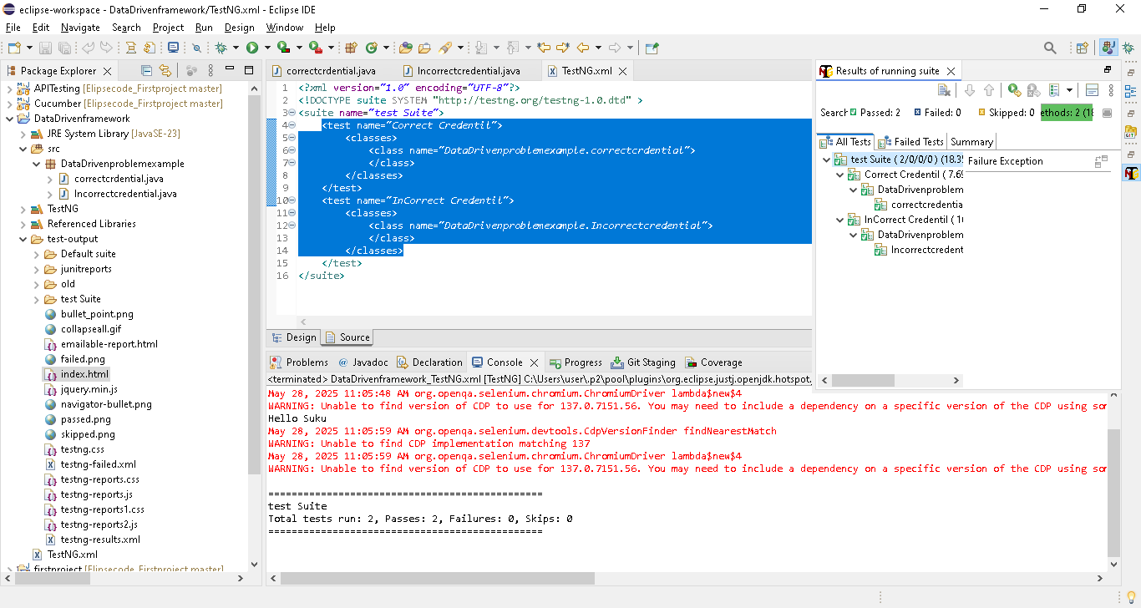
Now its showing 2 test
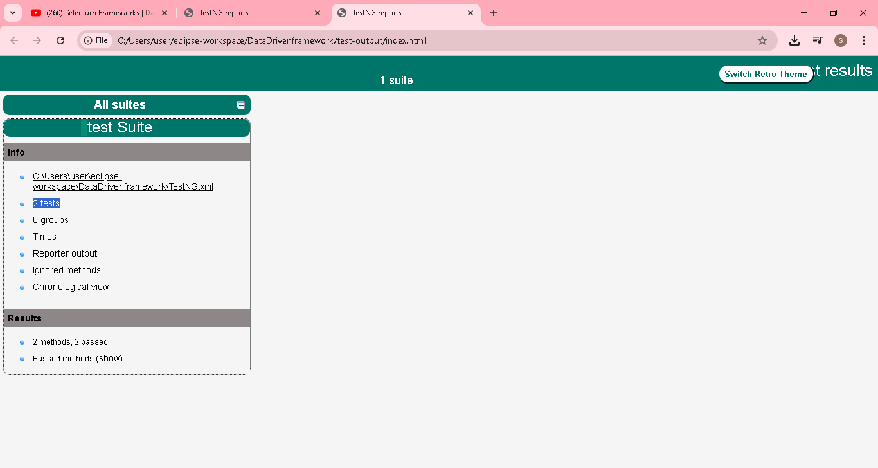
Now we are going to use @parameter & passing the values from testNG file
<?xml version="1.0" encoding="UTF-8"?>
<!DOCTYPE suite SYSTEM "http://testng.org/testng-1.0.dtd" >
<suite name="test Suite">
<test name="Correct Credentil">
<parameter name ="username" value ="admin"> </parameter>
<parameter name ="password" value ="admin123"> </parameter>
<classes>
<class name="DataDrivenproblemexample.correctcrdential">
</class>
</classes>
</test>
<test name="InCorrect Credentil">
<parameter name ="username" value ="admin123"> </parameter>
<parameter name ="password" value ="admin12345"> </parameter>
<classes>
<class name="DataDrivenproblemexample.Incorrectcredential">
</class>
</classes>
</test>
</suite>

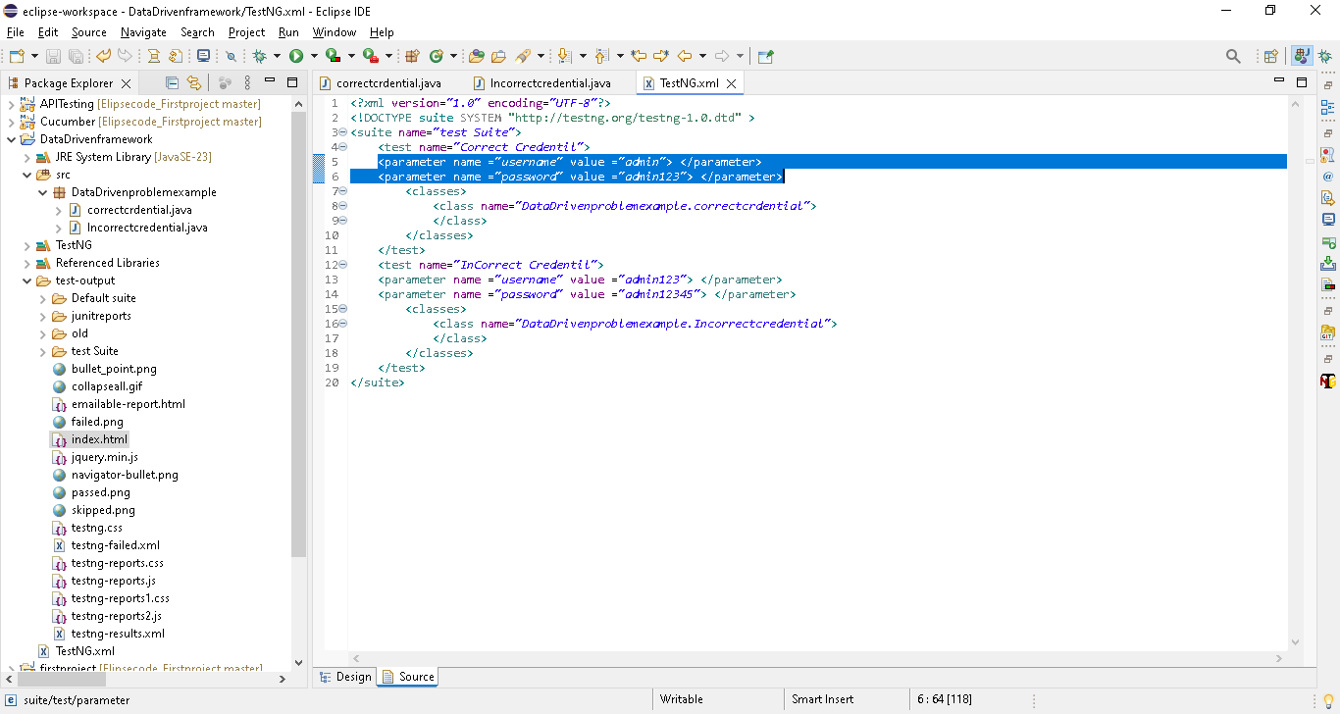
package DataDrivenproblemexample;

import java.time.Duration;

import org.openqa.selenium.By;
import org.openqa.selenium.WebDriver;
import org.openqa.selenium.WebElement;
import org.openqa.selenium.chrome.ChromeDriver;
import org.openqa.selenium.support.ui.ExpectedConditions;
import org.openqa.selenium.support.ui.WebDriverWait;
import org.testng.annotations.Parameters;
import org.testng.annotations.Test;

public class correctcrdential {

@Test
@Parameters({"username","password"})
public void correctcredential(String uName, String Pw) {
System.out.println("Hello Suku");

System.setProperty(
"webdriver.chrome.driver",
"C:\\Users\\user\\Downloads\\chromedriver.exe");
// Instantiate a ChromeDriver class.
WebDriver driver = new ChromeDriver();

//C:\Users\\user\\Downloads\\chromedriver-win64\\chromedriver-win64

// Maximize the browser
driver.manage().window().maximize();

// Launch Website
driver.get("https://opensource-demo.orangehrmlive.com/web/index.php/auth/login");

//wait
WebDriverWait driverWait = new WebDriverWait(driver, Duration.ofSeconds(30));
driverWait.until(ExpectedConditions.visibilityOfAllElementsLocatedBy(By.name("username")));

WebElement username = driver.findElement(By.name("username"));
username.sendKeys(uName);
WebElement Password = driver.findElement(By.name("password"));
Password.sendKeys(Pw);
WebElement btnlogin = driver.findElement(By.xpath("//button"));
btnlogin.click();
}

}

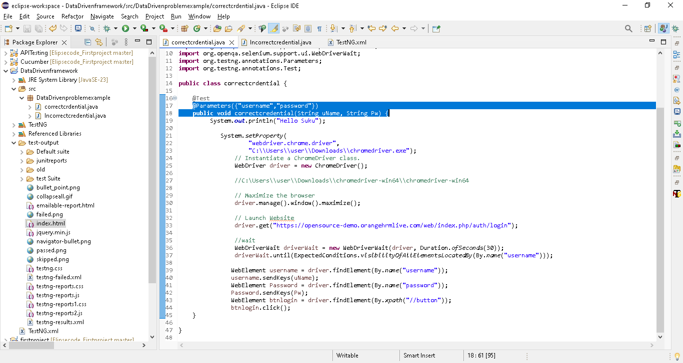
package DataDrivenproblemexample;

import java.time.Duration;

import org.openqa.selenium.By;
import org.openqa.selenium.WebDriver;
import org.openqa.selenium.WebElement;
import org.openqa.selenium.chrome.ChromeDriver;
import org.openqa.selenium.support.ui.ExpectedConditions;
import org.openqa.selenium.support.ui.WebDriverWait;
import org.testng.annotations.Parameters;
import org.testng.annotations.Test;

public class Incorrectcredential {

@Test
@Parameters({"username","password"})
public void Incorrectcredentialexample(String uName, String Pw) {
System.out.println("Hello Suku");

System.setProperty(
"webdriver.chrome.driver",
"C:\\Users\\user\\Downloads\\chromedriver.exe");
// Instantiate a ChromeDriver class.
WebDriver driver = new ChromeDriver();

//C:\Users\\user\\Downloads\\chromedriver-win64\\chromedriver-win64

// Maximize the browser
driver.manage().window().maximize();

// Launch Website
driver.get("https://opensource-demo.orangehrmlive.com/web/index.php/auth/login");

//wait
WebDriverWait driverWait = new WebDriverWait(driver, Duration.ofSeconds(30));
driverWait.until(ExpectedConditions.visibilityOfAllElementsLocatedBy(By.name("username")));

WebElement username = driver.findElement(By.name("username"));
username.sendKeys(uName);
WebElement Password = driver.findElement(By.name("password"));
Password.sendKeys(Pw);
WebElement btnlogin = driver.findElement(By.xpath("//button"));
btnlogin.click();
}

}

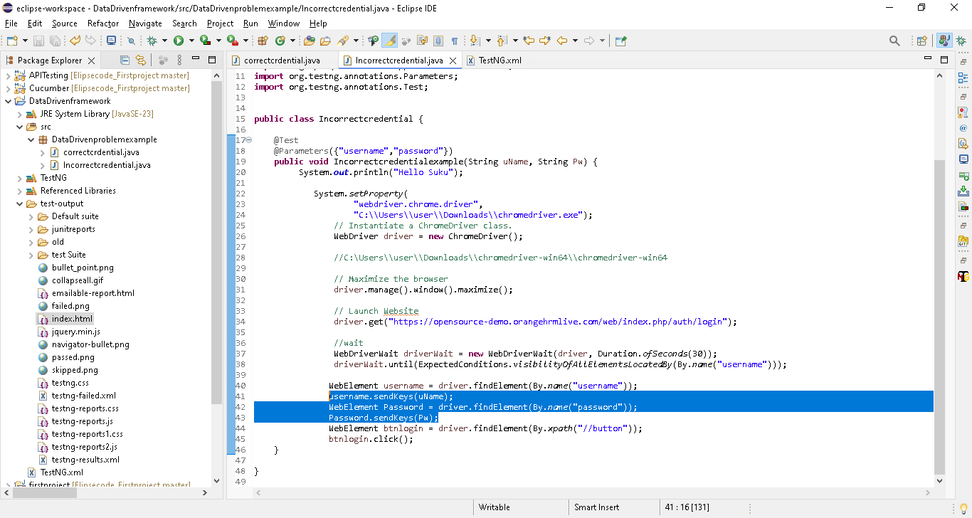

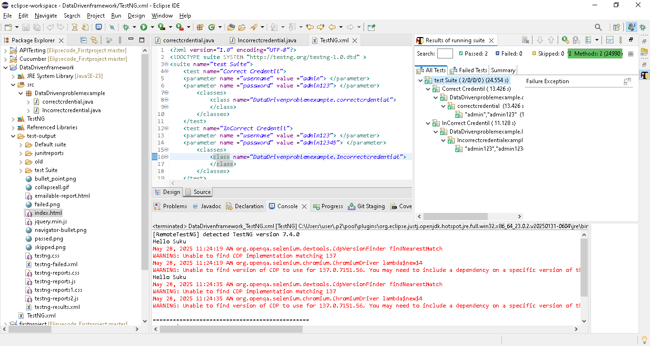

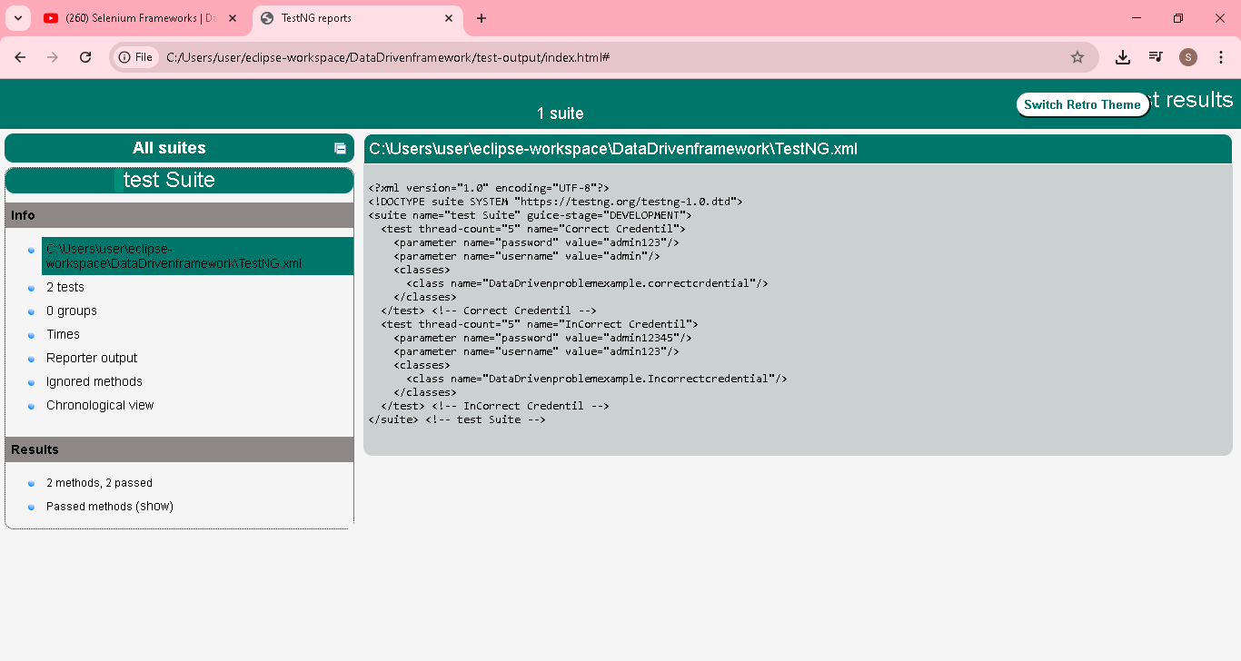
use @parameter not reduced the no of lines
Next video we will see, how to reduce the no of lines

Selenium Frameworks | Data-Driven | PART - 3 | Data providers in TestNG | How to use data providers

Passing the data on to the test cases is one of the core functionalities.
There are many ways to pass the data to test cases.
One among them is Data Providers annotation.
What will we learn in this video:
1. Data providers annotation
2. How to use data providers annotation to send data?
3. Disadvantages of using parameters for data-driven testing.
reduce the no of lines by using data provider
create a class & keep one login code
So modify the testng.xml first
<?xml version="1.0" encoding="UTF-8"?>
<!DOCTYPE suite SYSTEM "http://testng.org/testng-1.0.dtd" >
<suite name="test Suite">
<test name="Login to application">
<classes>
<class name="DataProvider.Dataproviderexamples">
</class>
</classes>
</test>

</suite>

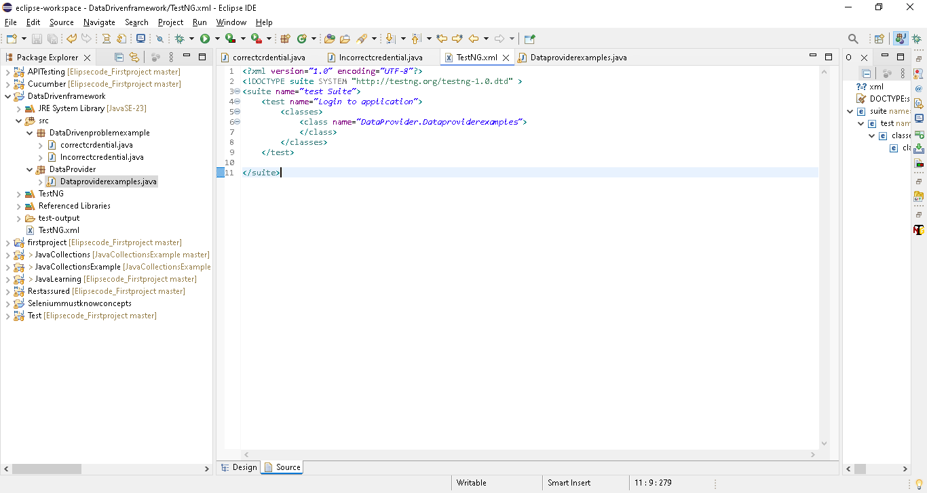

Then class
package DataProvider;

import java.time.Duration;

import org.openqa.selenium.By;
import org.openqa.selenium.WebDriver;
import org.openqa.selenium.WebElement;
import org.openqa.selenium.chrome.ChromeDriver;
import org.openqa.selenium.support.ui.ExpectedConditions;
import org.openqa.selenium.support.ui.WebDriverWait;
import org.testng.annotations.DataProvider;
import org.testng.annotations.Parameters;
import org.testng.annotations.Test;

public class Dataproviderexamples {

String [][] data = {
{"Admin","admin123"},
{"Admin123","admin12345"}
};

@DataProvider(name="Credential")
public String[][] dataprovider() {
return data;
}

@Test(dataProvider = "Credential")
public void correctcredential(String uName, String Pw) {
System.out.println("Hello Suku");

System.setProperty(
"webdriver.chrome.driver",
"C:\\Users\\user\\Downloads\\chromedriver.exe");
// Instantiate a ChromeDriver class.
WebDriver driver = new ChromeDriver();

//C:\Users\\user\\Downloads\\chromedriver-win64\\chromedriver-win64

// Maximize the browser
driver.manage().window().maximize();

// Launch Website
driver.get("https://opensource-demo.orangehrmlive.com/web/index.php/auth/login");

//wait
WebDriverWait driverWait = new WebDriverWait(driver, Duration.ofSeconds(30));
driverWait.until(ExpectedConditions.visibilityOfAllElementsLocatedBy(By.name("username")));

WebElement username = driver.findElement(By.name("username"));
username.sendKeys(uName);
WebElement Password = driver.findElement(By.name("password"));
Password.sendKeys(Pw);
WebElement btnlogin = driver.findElement(By.xpath("//button"));
btnlogin.click();
}

}

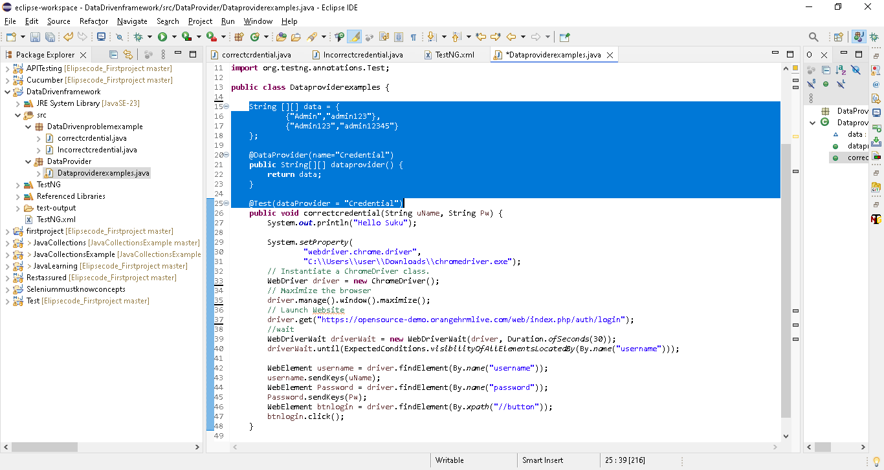

String [][] data = {
{"Admin","admin123"},
{"Admin123","admin12345"}
};

@DataProvider(name="Credential")
public String[][] dataprovider() {
return data;
}

@Test(dataProvider = "Credential")
public void correctcredential(String uName, String Pw) {
First we are creating 2 dimension array & storing the value in string data type
Then creating a method for dataprovider & getting the above 2 dimension array data value by using return data
Next in @test annotation, passing the dataProvider values..in will pass the repective value to uName & pw

Note imp: here 2 {} values present, so the method correctcredential will execute2 times..1 with first set of data{"Admin","admin123"}, 2 with second set of data{"Admin123","admin12345"}
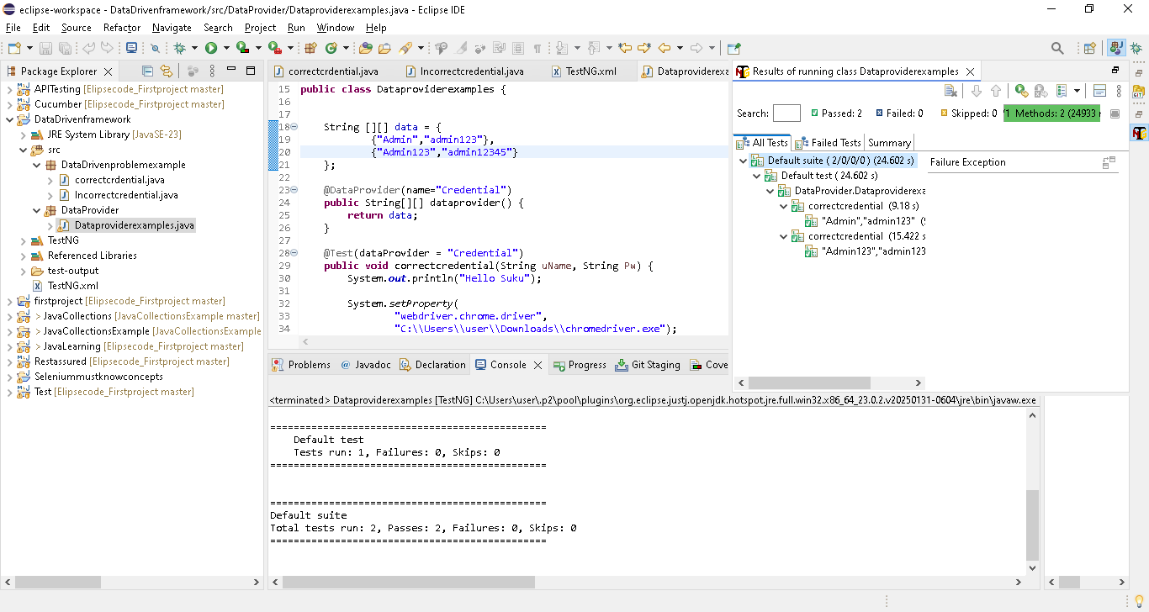

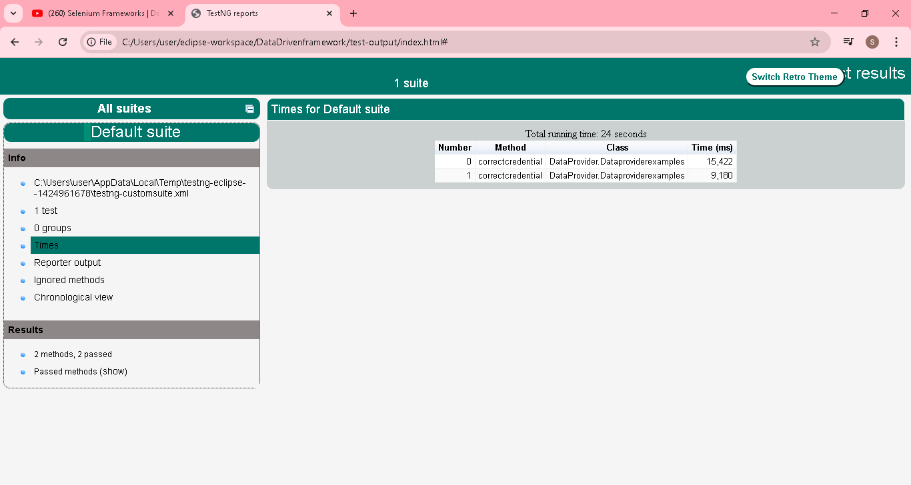 @ data provider reduce the no of lines, but the problem in data provider is test data we are passing inside the class..not in excel or testng..
Upcoming video we will see the how to pass from csv file..

Selenium Frameworks | Data-Driven | PART - 4 | Data providers & Excel Workbook | Using JXL library

Keeping the data in the excel sheet is one of the best ways to send data to our test cases. Reading data from excel is one of the complex operations.
But with the help of libraries like Apache POI or JXL, we can do this with ease.
NOTE: 99% of the data-driven testing follows this approach and this is the best and industry level practice. So master this video.
What will we learn in this video:
1. How to read test data from Excel?
2. Sending test data to data providers from Excel
3. JXL library
4. Iterating rows and columns in Excel using JXL library.
JXL JAR Download link: https://bit.ly/2CRaw7u
JXL JAR ->also called as Java excel jar
JXL library will support only “Excel 97-2003 workbook”.xls
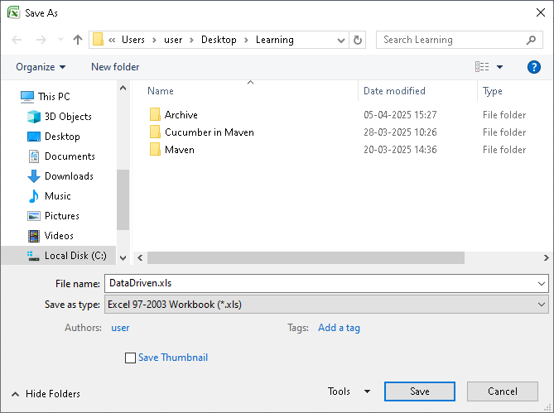

Jar downloaded
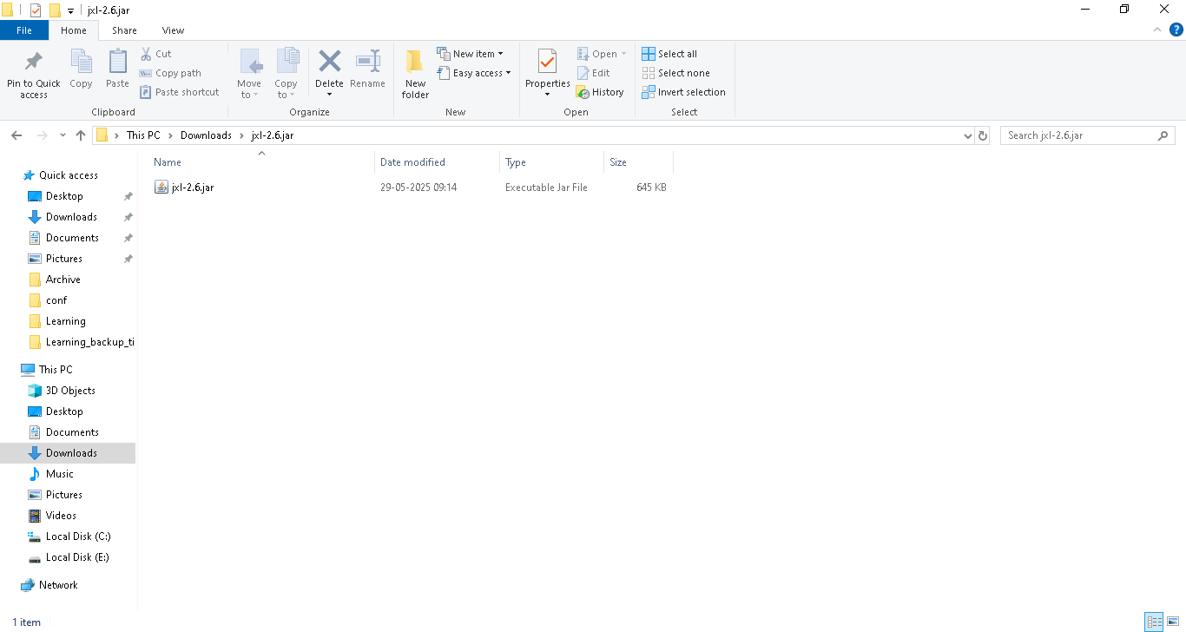

Add the jar to lib
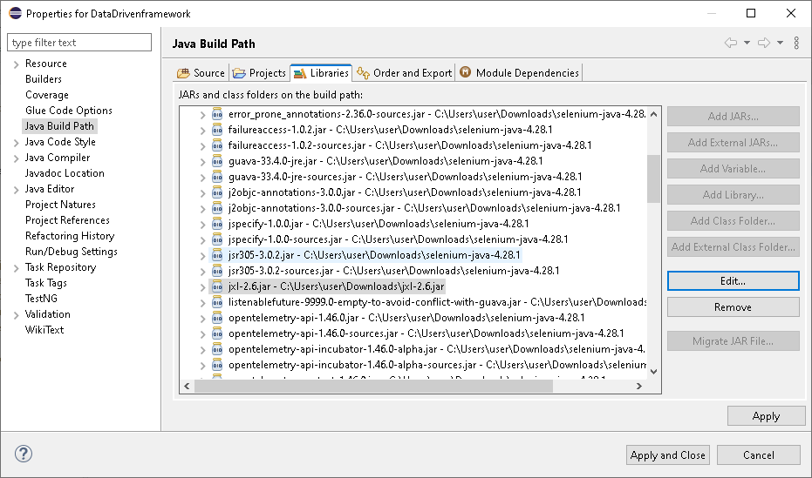

Steps
- File location
- Get workbook
- Get sheet
- Get row count
- Get column count
- Iterate row and column to read the cell value

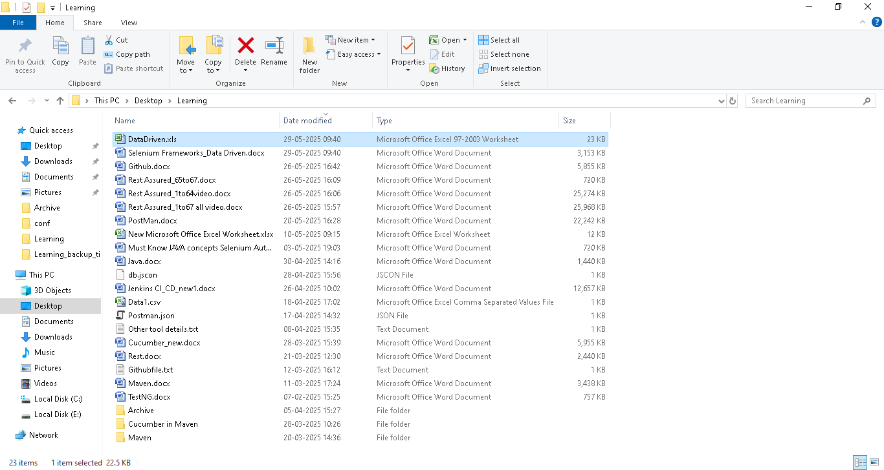



package JXLJarexample;

import java.io.FileInputStream;
import java.io.IOException;
import java.time.Duration;
import java.util.Iterator;

import org.openqa.selenium.By;
import org.openqa.selenium.WebDriver;
import org.openqa.selenium.WebElement;
import org.openqa.selenium.chrome.ChromeDriver;
import org.openqa.selenium.support.ui.ExpectedConditions;
import org.openqa.selenium.support.ui.WebDriverWait;
import org.testng.annotations.DataProvider;
import org.testng.annotations.Test;

import jxl.Sheet;
import jxl.Workbook;
import jxl.read.biff.BiffException;

public class JXLJardatadriven {

String [][] data = null;

public String[][] getexceldata() throws BiffException, IOException {

FileInputStream excel = new FileInputStream("C:\\Users\\user\\Desktop\\Learning\\DataDriven.xls");
Workbook workbook = Workbook.getWorkbook(excel);
//we can use index or sheet name as present in excel
Sheet sheet = workbook.getSheet(0);
int rowcount = sheet.getRows();
int columncount = sheet.getColumns();

//creating 2 dimensional array, array storeage/limit based on rowcount & columncount
//rowcount value is 5 including headers
//so rowcount-1 used...in array we only need 4 row, 2 column..that why
String testdata[][] = new String[rowcount-1][columncount];

//here we are using i as 1 bec first row in excel sheet is column name, so directly read from 2nd row
for (int i = 1; i < rowcount; i++) {
for (int j = 0; j < columncount; j++) {
//while storing in array, use i-1
//rowcount value is 5 including headers
//so rowcount-1 used...in array we only need 4 row, 2 column..that why
//note:getCell(j, i)..bec reading start from (0,1) cells in excel..i & j exchanged
testdata[i-1][j] = sheet.getCell(j, i).getContents();
}
}
return testdata;
}

@DataProvider(name="Credential")
public String[][] dataprovider() throws BiffException, IOException {
//getting the getexceldata() method return value & stored in data
data = getexceldata();
return data;
}

@Test(dataProvider = "Credential")
public void correctcredential(String uName, String Pw) {
System.out.println("Hello Suku");

System.setProperty(
"webdriver.chrome.driver",
"C:\\Users\\user\\Downloads\\chromedriver.exe");
// Instantiate a ChromeDriver class.
WebDriver driver = new ChromeDriver();
// Maximize the browser
driver.manage().window().maximize();
// Launch Website
driver.get("https://opensource-demo.orangehrmlive.com/web/index.php/auth/login");
//wait
WebDriverWait driverWait = new WebDriverWait(driver, Duration.ofSeconds(30));
driverWait.until(ExpectedConditions.visibilityOfAllElementsLocatedBy(By.name("username")));

WebElement username = driver.findElement(By.name("username"));
username.sendKeys(uName);
WebElement Password = driver.findElement(By.name("password"));
Password.sendKeys(Pw);
WebElement btnlogin = driver.findElement(By.xpath("//button"));
btnlogin.click();
}

}

First script go to correctcredential(String uName, String Pw) method..testng used with dataprovider..go it will immediately go to dataProvider method to get the data..then only it will go inside the method
First
@Test(dataProvider = "Credential")

public void correctcredential(String uName, String Pw)

second
here we are used getexceldata..it will go to getexceldata method to get the excl value & pass to main method correctcredential

@DataProvider(name="Credential")
public String[][] dataprovider() throws BiffException, IOException {
//getting the getexceldata() method return value & stored in data
data = getexceldata();
return data;
}

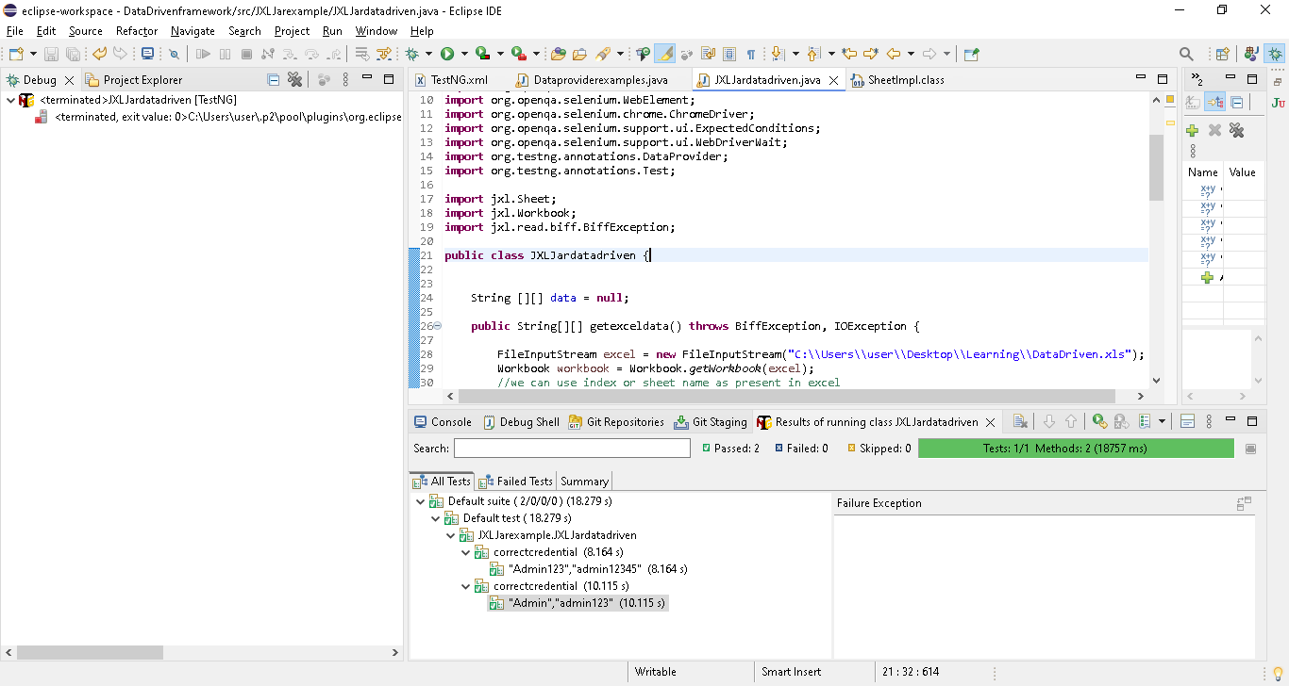

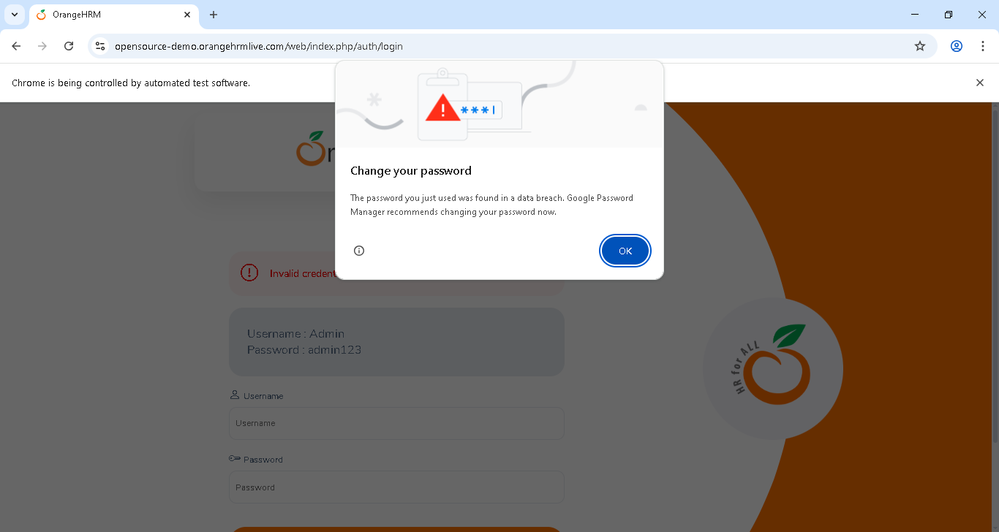

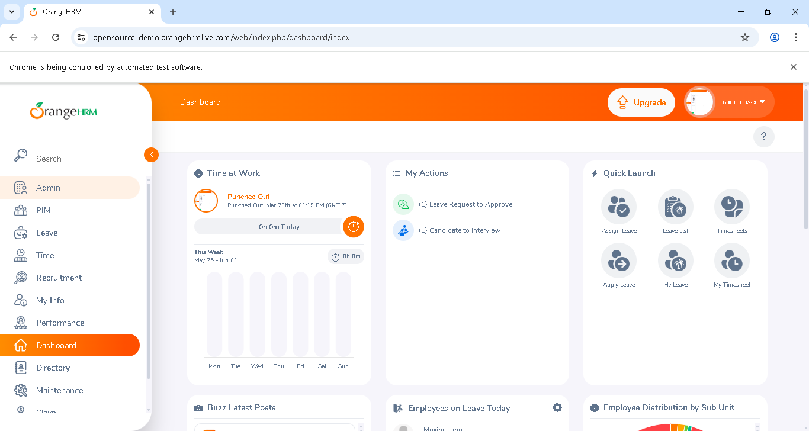

Selenium Frameworks | Data-Driven | PART - 5 | Java & Excel Workbook | Using POI library

Keeping the data in the excel sheet is one of the best ways to send data to our test cases. Reading data from excel is one of the complex operations. But with the help of libraries like Apache POI or JXL, we can do this with ease.
NOTE: Data-driven testing will incorporate Data providers annotation and that is the best and industry standard approach.
This video is to let you know the other possibility with simple Java and Apache POI library. This is for knowledge purpose.
What will we learn in this video:
1. How to read test data from Excel?
2. Sending test data to Java code from Excel
3. POI library
4. Iterating rows and columns in Excel using POI library.
Steps:
1.Read the file location
2.create object for workbook
3.go to sheet to work on
4.Row iteration and get the row value
5.Cell Iteration and get the cell value
HSSF,XSSF are classes
HSSF-> used in reading value from Microsoft Excel 2003 file
XSSF-> used in reading value from Microsoft Excel 2007 file & later
HSSFWorkbook and XSSFWorkbook -> Excel workbook
HSSFWorkbook and XSSFWorkbook -> are classes that act as an excel workbook

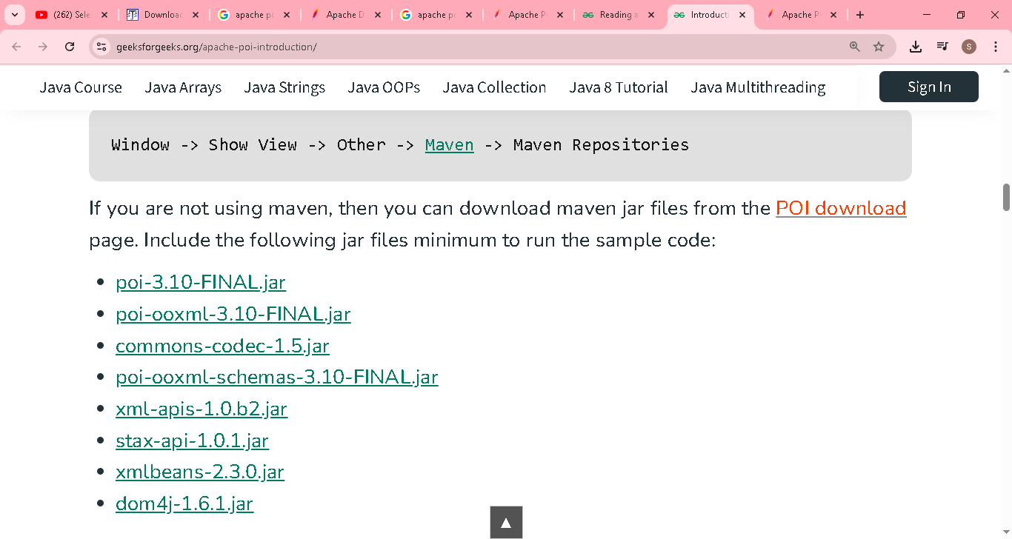

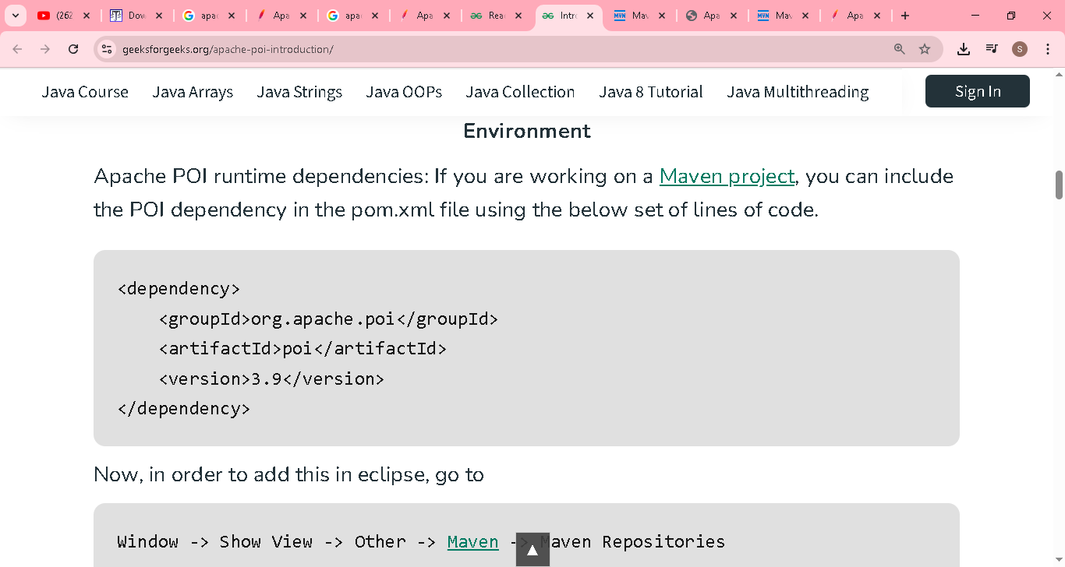

Its difficult to download one by one..so using maven in another project(test) porn xml
After downloaded, then i have added to this current project(DataDrivenframework)
(test) porn xml
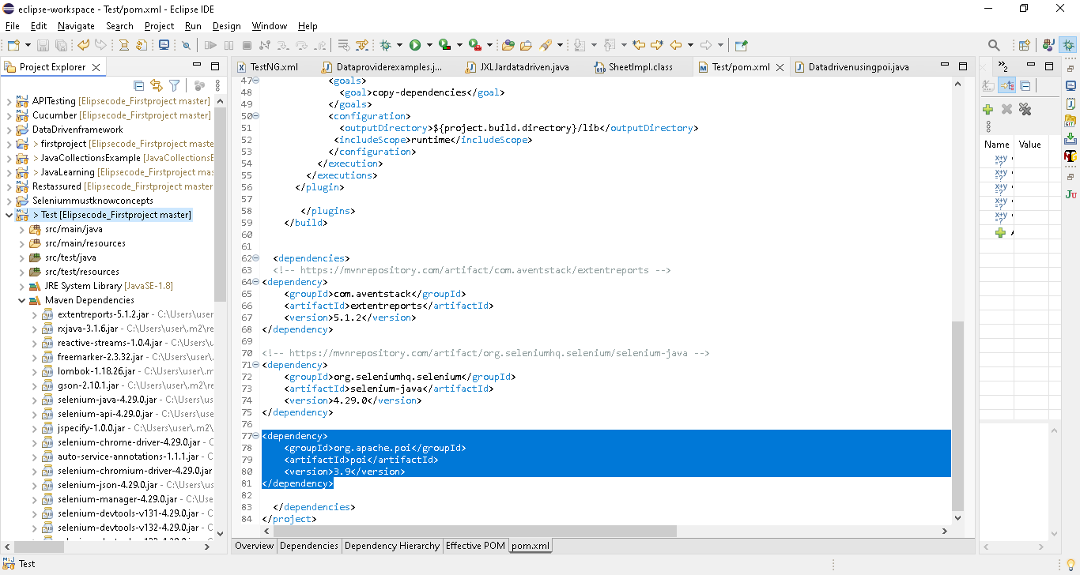

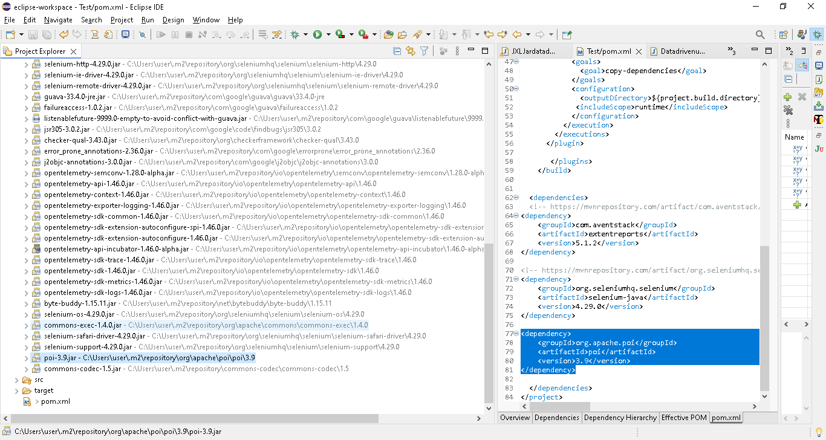

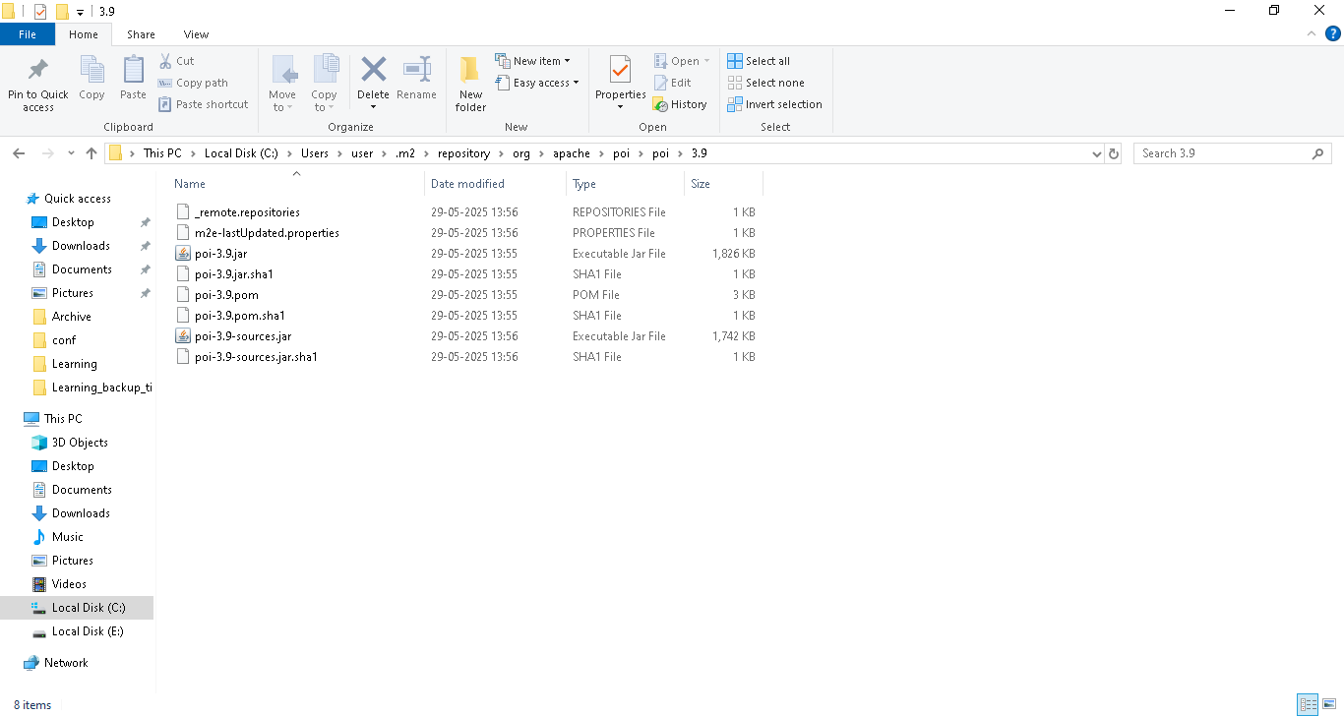

Add in current project(DataDrivenframework)

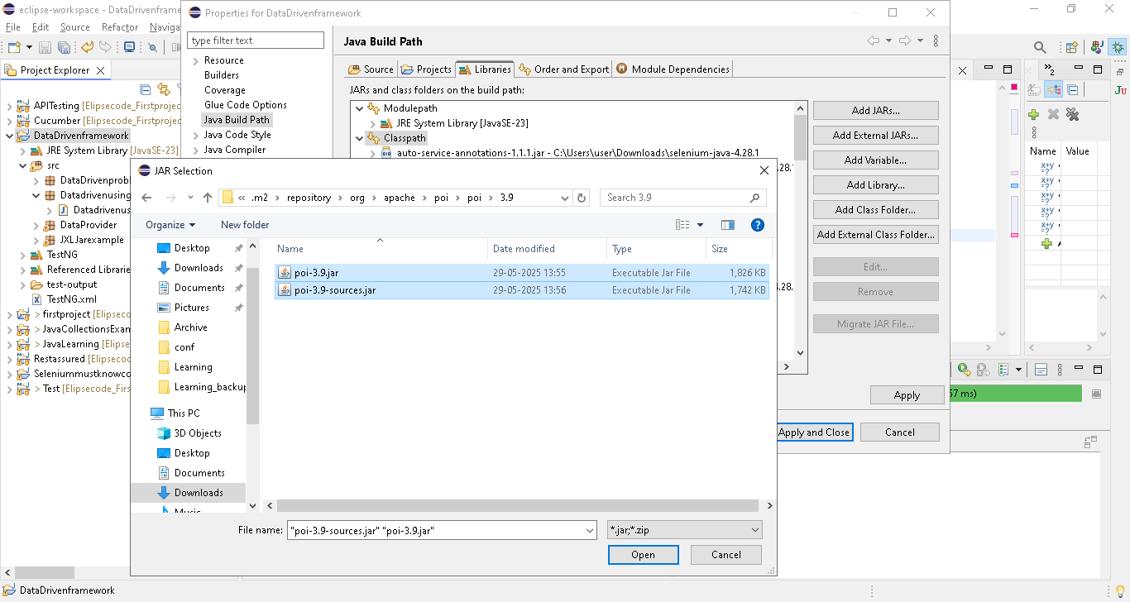

Create a new class

Here 1& 3 having username value , 2 & 4 having password value in the excel
Using below code
First time , save in usernamelist & next time passwordlist
%->reminder
if (i%2==0) {
usernamelist.add(celliterator.next().getStringCellValue());
}else {
passwordlist.add(celliterator.next().getStringCellValue());
}
i++;

full code
package Datadrivenusingapachepoi;

import java.io.FileInputStream;
import java.io.IOException;
import java.time.Duration;
import java.util.ArrayList;
import java.util.Iterator;
import java.util.List;

import org.apache.poi.hssf.usermodel.HSSFWorkbook;
import org.apache.poi.ss.usermodel.Cell;
import org.apache.poi.ss.usermodel.Row;
import org.apache.poi.ss.usermodel.Sheet;
import org.apache.poi.ss.usermodel.Workbook;
import org.openqa.selenium.By;
import org.openqa.selenium.WebDriver;
import org.openqa.selenium.WebElement;
import org.openqa.selenium.chrome.ChromeDriver;
import org.openqa.selenium.support.ui.ExpectedConditions;
import org.openqa.selenium.support.ui.WebDriverWait;

public class Datadrivenusingpoi {

static List<String> usernamelist = new ArrayList<String>();
static List<String> passwordlist = new ArrayList<String>();

public void readexcelvalue() throws IOException {
FileInputStream excel = new FileInputStream("C:\\Users\\user\\Desktop\\Learning\\DataDriven1.xls");
//using oldversion so using HSSF..need to import Workbook of poi lib
Workbook workbook = new HSSFWorkbook(excel);
Sheet sheet = workbook.getSheet("Sheet1");

//using iterator method, we are reading all the rows in a excel
Iterator <Row> rowiterator = sheet.iterator();
//then navigating each row, one by one using hasnext
//rowiterator.hasNext() ->true or false
//hasnext will navigate if next row contains value..if no values, it will come out
while (rowiterator.hasNext()) {
//storing first entire row in rowvalue using next
Row rowvalue = (Row) rowiterator.next();
//using cellIterator method, we are reading all the cells value in a row
Iterator <Cell> celliterator = rowvalue.cellIterator();
//then navigating each cell, one by one using hasnext
//celliterator.hasNext() ->true or false
//hasnext will navigate if next cell contains value..if no values, it will come out
int i = 2;
while (celliterator.hasNext()) {
//storing first cells value in cell using next
//getStringCellValue get the value as string from the cells
if (i%2==0) {
usernamelist.add(celliterator.next().getStringCellValue());
}else {
passwordlist.add(celliterator.next().getStringCellValue());
}
i++;
//System.out.println(cell);
}

}

}

public void Login(String uName, String Pw) {
System.out.println("Hello Suku");

System.setProperty(
"webdriver.chrome.driver",
"C:\\Users\\user\\Downloads\\chromedriver.exe");
// Instantiate a ChromeDriver class.
WebDriver driver = new ChromeDriver();
// Maximize the browser
driver.manage().window().maximize();
// Launch Website
driver.get("https://opensource-demo.orangehrmlive.com/web/index.php/auth/login");
//wait
WebDriverWait driverWait = new WebDriverWait(driver, Duration.ofSeconds(30));
driverWait.until(ExpectedConditions.visibilityOfAllElementsLocatedBy(By.name("username")));

WebElement username = driver.findElement(By.name("username"));
username.sendKeys(uName);
WebElement Password = driver.findElement(By.name("password"));
Password.sendKeys(Pw);
WebElement btnlogin = driver.findElement(By.xpath("//button"));
btnlogin.click();
}

//need to execute 2 times , bec correct & incorrect credential, so using for
public void execute() {
for (int i = 0; i < usernamelist.size(); i++) {
//calling login method & pass the values
Login(usernamelist.get(i), passwordlist.get(i));
}
}
public static void main(String[] args) throws IOException {
// TODO Auto-generated method stub
Datadrivenusingpoi datadrivenusingpoi = new Datadrivenusingpoi();

datadrivenusingpoi.readexcelvalue();
System.out.println(datadrivenusingpoi.usernamelist);
System.out.println(datadrivenusingpoi.passwordlist);
datadrivenusingpoi.execute();
}

}

